**Project: Working with data**

**My working dashboards is**

## [Malaria in Africa](https://public.tableau.com/en-us/s/gallery/malaria-africa?gallery=featured)

## Insight one:

## 

## “The darkest shading area in map is Kenya it is the most affected countries in Africa and that related to high number of deaths due to malaria from 2000 to 2010 but it showed improvement begin from 2011 and the Deaths per year due to malaria became less than Africa average ”

## Insight two:

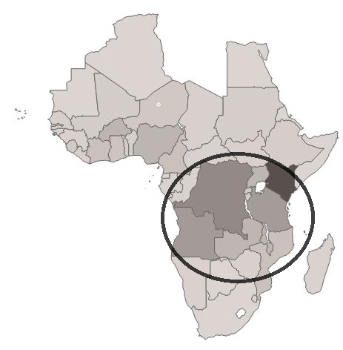

**“Countries in Central of Africa have the most area affected with malaria It have the darkest shading in the map”**

## Insight three:

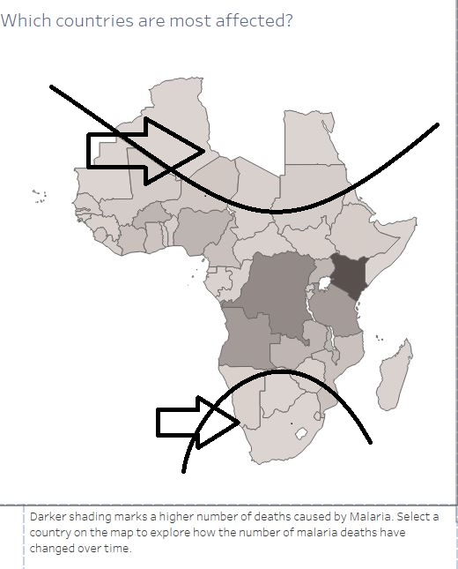

**“Countries in North and South of Africa have the least number affected with malaria it have the light shading in the map”**